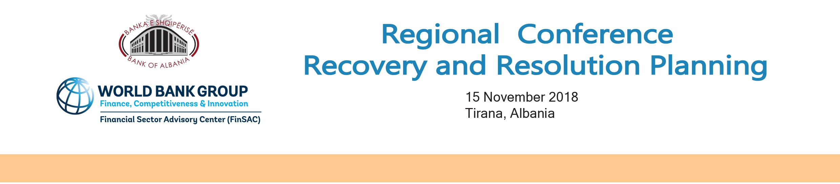

Agenda

09:00 – 09:20 | Opening remarks by Natasha AHMETAJ, Second Deputy Governor, Bank of Albania
09:20 – 09:30 | Group Photo (all speakers and moderators)
09:30 – 10:30 | Panel 1: Recovery planning: History and issues to be addressed  Moderator: Denada Prifti, Head of Unit C3, Bank Resolution, Planning & Decisions, Single Resolution Board
09:30 – 10:00 | First experience of Bank Recovery planning under the new Resolution Law  Manjola Mançe, Head of Supervision of Individual Institutions Section, Supervision Department, Bank of Albania
10:00 – 10:30 | Recovery and resolution planning from a bank’s perspective  Eduardo Ávila Zaragoza, Head of Global Supervisory Relations, Banco Bilbao Vizcaya Argentaria Bank (BBVA)  Elsa Martinez, Head of Resolution Planning Office, BBVA
10:30 – 11:00 | Coffee break
11:00 – 12:00 | Panel 2: Recovery and Resolution Planning in EU: Developments and Cooperation Framework  Moderator: Juan Ortiz, Senior Financial Sector Specialist, FinSAC, World Bank
11:00 – 11:30 | Topical development in recovery planning in the EU  Wolfgang Johann Gerken, Head of Section DGMS1 – Microprudential Supervision, European Central Bank  Kathrin Zander, Supervisor DGMS1 – Microprudential Supervision, European Central Bank
11:30 – 12:00 | Recent developments in resolution planning in the EU  Denada Prifti, Head of Unit C3, Bank Resolution, Planning & Decisions, Single Resolution Board
12:00 – 13:30 | Lunch
13:30 – 14:30 | Panel 3: Resolution planning: Challenges ahead for small host countries  Moderator: Deniz Deralla, Director, Supervision Department, Bank of Albania
13:30 – 14:00 | The first round of resolution planning in Albania  Vasilika Kota, Director, Resolution Department, Bank of Albania
14:00 – 14:30 | The experience of Croatia in operationalizing RRP  Roman Šubić, Vice Governor, Croatian National Bank
14:30 – 15:00 | Coffee break
15:00 – 16:00 | Panel 4: Resolution strategies and executions: lessons learned so far  Moderator: Vasilika Kota, Director, Resolution Department, Bank of Albania
15:00 – 15:30 | Defining resolution strategies  Radek Urban, Executive Director, Resolution Department, Czech National Bank
15:30 – 16:00 | Lessons learned from recent bank resolution cases in Italy  Sabrina Bellacci, Head of Resolution 1 Division, Italian Resolution Authority, Bank of Italy
16:00 – 16:30 | Closing remarks, BoA, FinSac

