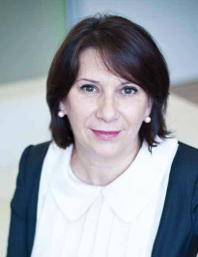 |  | Luljeta MINXHOZI  First Deputy Governor  Bank of Albania

Prof. Dr. Luljeta Minxhozi was appointed First Deputy Governor of the Bank of Albania on 9 January 2019. She joined the Bank as a member of the Supervisory Council in December 2018.

Prof. Dr. Minxhozi graduated in Economics from the University of Tirana, in 1982 and holds the title Professor since 2011. Between 1982 and 2017, she attended a series of academic programmes in renowned European universities.

Her teaching career started in 1982, at the Faculty of Economics, University of Tirana, to be later enriched by other teaching experiences in a number of universities. Notably, she served as the Dean of the Faculty of Economics at the European University of Tirana over the period 2008 - 2018, and as the Vice Rector of Luarasi University in 2018.

Throughout her extensive academic experience, Prof. Dr. Minxhozi has been engaged as a lead professor in various subjects of economics and finance in a number of universities in Albania and abroad. Her rich bibliography of works includes numerous economic studies, scientific articles, academic publications, university textbooks and monographs.

She has also delivered a series of lectures in many national and international conferences, contributing to academic and economic debate.

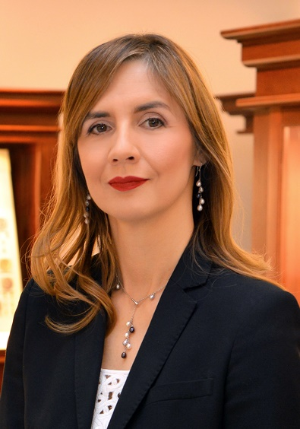 |  | Anita ANGELOVSKA BEZHOSKA  Governor  National Bank of the Republic  of North Macedonia

Anita Angelovska Bezhoska is Governor of the National Bank of the Republic of North Macedonia since May 2018, after almost twelve years of work experience in the institution, first as a chief economist and almost eight years as a Vice-Governor.

Previously, she worked at the International Monetary Fund (IMF) and the Ministry of Finance – first as a head of the project for establishing a treasury system and then, as a state treasurer and state secretary.

In 2015, she received her doctorate from the Faculty of Economics in Ljubljana, Slovenia. She is the author of several expert and research papers.

Angelovska Bezhoska is member of the Steering Committee of the Vienna Initiative 2, as representative of the Western Balkans countries.

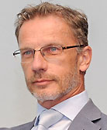 |  | Boris VUJČIĆ  Governor  Croatian National Bank

Boris Vujčić holds a PhD in Economics from the University of Zagreb. He has also received diplomas in Economics from the Montpellier University (France) and was a pre-doctoral PhD Fulbright student at the Michigan State University.

He joined the Croatian National Bank in 1997, and was Director of the Research Department for three years before becoming Deputy Governor in 2000, a position to which he was re-appointed in 2006.

In July 2012, Mr Vujčić became Governor of the Croatian National Bank for a six-year term of office and was re-appointed for another six-year term of office in July 2018.

Mr Vujčić has been a Deputy Chief Negotiator in Republic of Croatia’s negotiations with the European Union 2005-2012.

He was also a member of the Global Development Network (GDN) Board in the same period, 2005-2012.

He is also a Member of the Steering Committee of the ESRB, since 2016, a Chairman of the Steering Committee of the Vienna Initiative, since 2016, and a Member of the General Council of the ECB, since 2013.

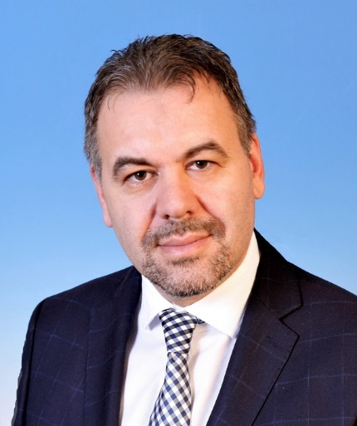 |  | Leonardo BADEA  Deputy Governor  National Bank of Romania

Mr Leonardo Badea is the Deputy Governor of the National Bank of Romania since October 2019.

From June 2017 to October 2019, Mr Badea was the President of the Financial Supervisory Authority in Romania.

With an experience of almost 20 years in the field of economic higher education, Mr Leonardo Badea was vice-rector of the University of Valahia in Târgovişte and Dean of the Faculty of Economics within the same university.

Mr Badea was consecutively appointed as senator and deputy in the Romanian Parliament, holding the positions of Secretary of the Committee for Budget - Finance, Banking and Capital Market in the Senate of Romania and of Chairman of the Committee for Budget - Finance in the Chamber of Deputies.

Mr Leonardo Badea holds a PhD in accounting from the Academy of Economic Studies in Bucharest, has graduated the Postdoctoral School of Economics of the Romanian Academy and, as well, the course - Financial Markets by Yale University on Coursera, hold by professor Robert J. Shiller. He is also a member of the European International Business Academy (EIBA) and a Member of the Center for International Development Studies and Economic and Social Movements (CEDIMES).

Mr Leonardo Badea has a sustained activity in the editorial and scientific councils of economic publications, being editor of the scientific council of the “Journal of Accounting, Finance and Auditing Studies” in Turkey, editor of the scientific council of the “Valahia Journal of Economics Studies”, CNCSIS B +, member of the editorial board of “Theorethical and Applied Economics”, CNCSIS B + and of the Journal of Financial Studies.

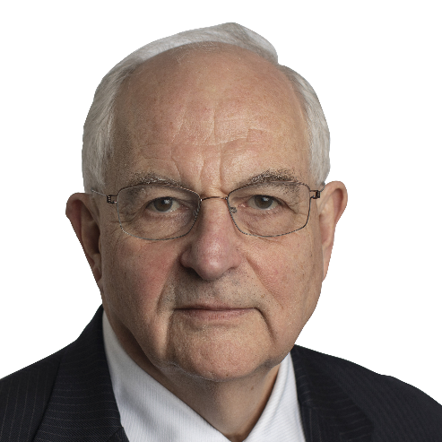 |  | Martin WOLF  Chief Economics Commentator  Financial Times

Martin Wolf is chief economics commentator at the Financial Times, London.

He was awarded the CBE (Commander of the British Empire) in 2000 “for services to financial journalism”.

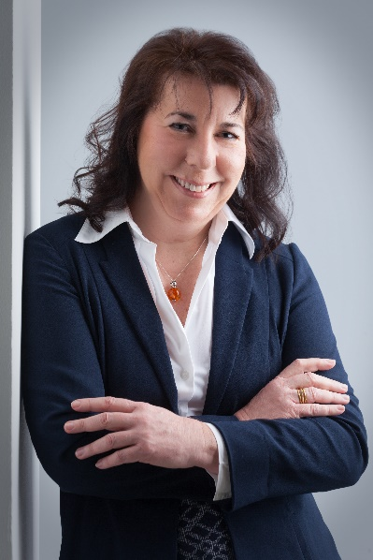 |  | Doris RITZBERGER-GRÜNWALD  Director  Economic Analysis and  Research Department  Oesterreichische Nationalbank

Doris Ritzberger-Grünwald was born in Vienna (Austria) in 1961.

She obtained her Master’s degree in social and economic sciences from the University of Vienna in 1985, completed the Program in Economics at the Institute for Advanced Studies (IAS) in Vienna in 1987 and obtained her Doctoral degree in social and economic sciences from the University of Vienna in 1991.

Following a period as research assistant at the IAS from 1987 to August 1988, she joined the Oesterreichische Nationalbank in 1988, where she started as an economist in the Economic Analysis Division and then moved to the Foreign Research Division.

After an interim position as assistant to a Member of the Governing Board she returned to the Foreign Research Division as special adviser, to be promoted in 2000 to the post of Deputy Head of Division.

From June 2002 to April 2013 she served as Head of the Foreign Research Division.

In May 2013 she was appointed as the OeNB's chief economist (Director of the Economic Analysis and Research Department).

Her fields of policy-oriented research include monetary policy, economic growth, convergence issues, inflation, the enlargement of the European Union and the European Monetary Union, with a special focus on Central, Eastern and South-Eastern European Countries.

She is a member of the Monetary Policy Committee of the European Central Bank and an Executive Board Member of the Joint Vienna Institute.

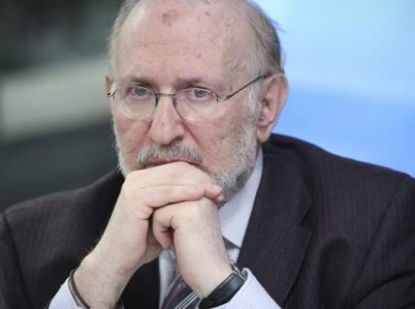 |  | Mario I. Blejer  Former Governor  Central Bank of Argentina  and  LSE Visiting Professor

Mario I Blejer is Visiting Professor in the Institute of Global Affairs at LSE and Board Director,
IRSA, Argentina.

Previously, Mario has held the positions of Governor of the Central Bank of Argentina and
Executive Director of the Bank of England, and held senior positions at the IMF and the WB.

He also held the Walter Rathenau Chair in European Economics and Director of the Helmut
Kohl Institute at the Hebrew University of Jerusalem.

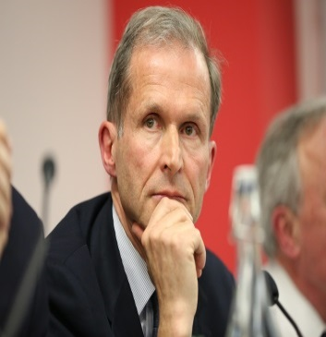 |  | Erik BERGLOF  Professor  LSE & Chief Economist, AIIB

Erik Berglof is the inaugural Chief Economist at the Asian Infrastructure Investment Bank.

Before joining AIIB, he was Director of the Institute of Global Affairs at the LSE School of Public Policy and Chief Economist of the European Bank for Reconstruction and Development.

Professor Berglof has published widely in top journals on economic and political transition, corporate governance, financial development, and EU reform.

He was a member of the Secretariat for the G20 Eminent Persons Group on Global Financial Governance, EU Wise Persons Group on European Development Finance Architecture, and the World Economic Forum Global Futures Council on the Financial and Monetary Systems.

Natasha AHMETAJ

Second Deputy Governor
Bank of Albania

Dr Natasha Ahmetaj currently serves as Second Deputy Governor of the Bank of Albania, since 6 May 2015, and member of the Supervisory Council of the Bank of Albania, since December 2014.

She graduated with a bachelor’s degree in 1987 from the Faculty of Economics, University of Tirana and received a Masters in Economy in 2000 and Doctor of Sciences in Economy in 2004, from the same University.

Dr Ahmetaj started her academic career in 1994. In the period 1994-2001, she was a lecturer on Macro economy; Micro economy; and Monetary economy. During this period, she advanced in her academic career serving as the Head of the Business Administration Department and later as the Dean of the Faculty of Trade, at Ismail Qemali University, in Vlora, Albania.

In 2001, she started a career in banking upon her appointment as the Director of the National Commercial Bank (BKT) in Vlora. Dr Ahmetaj has advanced in her career in banking, and her progressively more senior positions included the Head of Network and later Administrator of the National Commercial Bank (BKT). She held this position until her election as a member of the Supervisory Council of the Bank of Albania.

During her long career, Dr Ahmetaj has received many awards and certificates from reputable academic and financial institutions.

Dr Natasha Ahmetaj has authored numerous articles and publications on a variety of topics, including economics, central banking, and financial issues.

She is fluent in English. Dr Ahmetaj is married and has a son.

Andrés VELASCO

Professor
Dean, LSE School of Public Policy

Andrés Velasco is Professor of Public Policy and Dean of the School of Public Policy at the
London School of Economics and Political Science.

In 2017-19 he was a member of the G20 Eminent Persons Group. During 2015-16 he cochaired
the Global Panel on the Future of the Multilateral Lending Institutions. In 2013-16 he was a member of the Global Oceans Commission. Mr. Velasco ran for the presidency of Chile in the June 2013 primaries. He also was the Minister of Finance of Chile between March 2006 and March 2010. During his tenure he was recognized as Latin American Finance Minister of the Year by several international publications. His work to save Chile´s copper windfall and create a rainy-day fund was highlighted in the Financial Times, the Economist, the Wall Street Journal and Bloomberg, among many others.

In 2013-17 Mr. Velasco served as Professor of Professional Practice in International Development at the School of International and Public Affairs, Columbia University. In 2000-06 he was Sumitomo-FASID Professor of International Finance and Development at the Harvard Kennedy School. Earlier he was Associate Professor of Economics and Director of the Center for Latin American and Caribbean Studies at New York University.

He received a B.A. in economics and philosophy and an M.A. in international relations from Yale University. He also holds a Ph.D. in economics from Columbia University and was a postdoctoral fellow in political economy at Harvard University and the Massachusetts Institute of Technology. He is the author of nearly one hundred academic articles, several academic books and two novels. He was president of the Latin American and Caribbean Economic Association (LACEA) from 2005 to 2007. In February 2006 he received the Award for Excellence in Research from the Inter-American Development Bank. He has served as a consultant to the International Monetary Fund, the World Bank, the Inter-American Development Bank, and to governments, central banks and private businesses around the world. He has served on corporate boards and international advisory boards for several international firms.

He is married to Consuelo Saavedra, a journalist and anchorwoman. They have three children: Rosa, Ema and Gaspar.

Yan SUN

Mission Chief for Albania
International Monetary Fund

Yan Sun is Advisor in the IMF’s European Department and mission chief to Albania.

Prior to that, she was in the IMF’s Strategy, Policy and Review Department overseeing and signing off surveillance and program country reports.

She joined the IMF in 2000 and has worked on a wide range of country and policy issues, including the Managing Director’s Global Policy Agenda, Vulnerability Exercise for Emerging Markets, and international monetary system.

Ms. Sun holds a PhD in Economics from New York University.

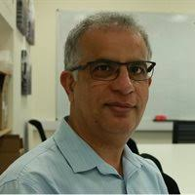 |  | Adnan KHAN  Professor  LSE School of Public Policy

Before joining the School of Public Policy and STICERD, Professor Khan served as Research and Policy Director at the International Growth Centre at the LSE for ten years.

During 2018-19, he was a Visiting Lecturer of Public Policy at the Harvard Kennedy School.

Professor Khan has spent more than 15 years in the policy world as a practitioner, policymaker and activist, and more than 10 years in the research world as an instructor, researcher and as a catalyser of other people’s research.

His areas of interest include economic development and state capacity, political economy and state fragility, and public finance.

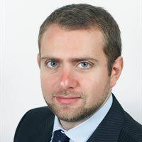 |  | Riccardo CRESCENZI  Professor  LSE Department of Geography and Environment

Riccardo Crescenzi is a Professor of Economic Geography at the London School of Economics and is the current holder of a European Research Council (ERC) Grant. He is also an Associate at the Centre for International Development, Harvard Kennedy School of Government, Harvard University and he is affiliated with the European Institute, Centre for Economic Performance (CEP) and the Spatial Economics Research Centre (SERC) at the LSE.

He has been a Jean Monnet Fellow at the European University Institute (EUI) and a Visiting Scholar at the Harvard Kennedy School of Government, Taubman Centre, Harvard University and at the University of California Los Angeles (UCLA).

He has provided academic advice to, amongst others, the European Investment Bank (EIB), the European Parliament, the European Commission (DG Regional Policy), the Inter-American Investment Bank (IADB) and various national and regional governments.

His research is focused on regional economic development, innovation, Foreign Direct Investment (FDI) and multinationals and the analysis and evaluation of European Union policies. His 5-year ERC research project looks at the location strategies of FDI around the world, at their impacts on the host economies and at the evaluation of policies for the attraction and retention of FDI.

