FINANCIAL AND BORROWING SITUATION OF ENTERPRISES IN ALBANIA

2021 H1

FINANCIAL STABILITY DEPARTMENT

August 2021

CONTENTS

Summary of key findings of the Survey 2
1. Activity’s main characteristics 4
2. Financial performance of enterprises and the presence of debt 7
3. Characteristics of enterprise borrowing 12
4. Debt structure 14
5. The debt burden 16
6. Relations with banks and expectations for the future 19

Summary of key findings of the Survey

The survey was conducted with a sample of 1.374 enterprises (small, medium-sized and large enterprises) across the country, operating in major sectors of the economy. Around 82% of the total of the surveyed enterprises responded to the questions in the questionnaire, completely or partially. Survey estimates were based on the number and type of the respondent enterprises.

• FINANCIAL SITUATION

During 2021 H1 (hereinafter, “the period”), the surveyed enterprises highlight that “the situation created by the pandemic” continues to have an impact on their activity, affecting other issues as well faced by them mainly related with: “competition”; “finding a market”; “access to financing” and the “availability of a qualified staff”. Small and medium-sized enterprises have appeared more sensitive.

Sales performance and financial result appear improved compared with 2020 H2, although small and medium-sized enterprises continue to report a negative net balance. Around 87% of each size group reported profits during the period. The share of enterprises that reported profits has increased for all three groups of enterprises, compared to the previous period. Expectations in terms of overall sales and financial result for the next six months appear quite positive for all sizes of enterprises.

Regarding activity expansion or investments increase, small and large enterprises report an expansion of activity, whereas medium-sized enterprises continue to present a slight contraction for the period. The pandemic continues to impact the enterprises decision-making regarding investments or the expansion of their activity. Expectations for enterprises of all sizes appear positive for the next six months.

During the period, less than half of the total responding enterprises financed their activity through sales. Reliance on this source alone contracted for all three groups of enterprises. Meanwhile, the inclination to combining different sources of financing continues to account for a considerable share for the period and has expanded for all enterprises. Financing achieved through the combination of sales with accumulated reserves has the main share in this regard.

• BORROWING

Around 40% of the total responding enterprises (454 enterprises) state that they are currently indebted. This share has registered a decrease by 0.9 p.p. compared to the previous six months, and has increased by 0.7 p.p. compared to the previous year. In terms of enterprises’ size, the share of borrowing enterprises has decreased for small and large enterprises, by 3.6 p.p. and 0.8 p.p., respectively, while this share increased by 0.5 p.p for medium-sized enterprises.

In total, formal sources of borrowing (from banks and non-bank financial institutions) are used by 92% of borrowing enterprises, 2 p.p. higher than in the previous six-months. Around 90% of the total borrowing enterprises claim to have borrowed from banks, 2.1 p.p. higher than in 2020 H2. The combination of formal and informal sources has been used by 3.4% of enterprises.
Compared with the previous period, the share of total borrowing enterprises that have borrowed for an investment has registered a decline for small and medium-sized enterprises, whereas borrowing to cover short-term expenditures continued to increase for all sizes of enterprises. Around 77% of small borrowing enterprises, around 85% of medium-sized enterprises and 87% of large enterprises consider their level of borrowing for financing their activity as adequate. Compared with the previous period, this share has increased for all sizes of enterprises.

Borrowing is denominated in the domestic currency for 60% of small enterprises, 65% of medium-sized enterprises and 45% of large enterprises, while the rest is in foreign currency and/or combined. Borrowing in foreign currency (mainly in euro) was more used by large enterprises (around 41%) and less by small and medium-sized enterprises (respectively 36% and 31%).

The total value of debt is approximately half of the value of the enterprise's equity for around 74% of total borrowing enterprises and almost at the same level of the value of equity for around 13% of them. Analysed by size, the debt/equity ratio resulted higher for small and medium-sized enterprises, with 26% and 34% of them declaring that this ratio is equal or exceeds the value of equity, implying a higher debt burden. For this six-month, this ratio increased for all sizes of enterprises. By sectors, debt burden increased for all analysed sectors and appears higher for enterprises of construction and trade sectors.

• RELATIONS WITH BANKS

Bank borrowing is assessed between “normal” and “difficult”, unchanged compared with the previous period. The relationship with banks continues to be assessed between “important” and “necessary”. The high cost of loans continues to be considered as the main constraining factor in obtaining a bank loan, particularly for small enterprises. However, the assessment for this factor has resulted in decline in this six-month period for both medium-sized and large enterprises.

Regarding plans to request a loan in the future, almost half of the responding enterprises reported “no likelihood” of requesting a bank loan in the next period. This share has recorded an increase for all sizes of enterprises compared with the previous periods. Furthermore, an increase is observed in the share of enterprises that claim that it is “somewhat likely” to take a loan in 2021 H2, as well as in the share of small and large enterprises that declare it is “very likely” for this to happen in the next period. On the other hand, there is a slight increase for the alternative “definitely” for all sizes of enterprises, although this alternative accounts for the smallest share.

Financial and borrowing situation of enterprises in Albania

Sample characteristics. In 2021 H1, (hereinafter, “the period”) the survey was conducted on a sample of 1374 enterprises in the 12 districts across the country. Most enterprises (78%) are located in the four major counties, namely: Tirana (around 53%), Durrës (around 15%), Fier (around 6%) and Shkodra (around 4%).

In the total sample, 82% of the enterprises (1127 in total) responded to the survey questionnaire and the analysis of the results is based on these responses. The following analysis is largely based on enterprise breakdown by size.

1. Activity’s main characteristics

1.1 Enterprises by sector and size
By sectors, for 2021 H1, around 36% of enterprises belong to the industry sector, around 30% belong to the services sector, around 15% belong to the construction sector, and around 19% to the trade sector. By size, around 23% of enterprises are classified as small enterprises (5-19 employees), around 16% as medium-sized enterprises (20-49 employees) and 61% as large enterprises (over 50 employees). In the group of small enterprises, those operating in the services sector (around 40%) account for the main share, followed by the trade sector (around 27%). On the other hand, the industry sector (with around 39% and 40%, respectively) and the services sector (29% and 27%, respectively) have the higher share in the group of medium-sized and large enterprises.

Chart 1.1 Distribution of enterprises by size | Chart 1.2 Distribution of enterprises by size and sector of the economy
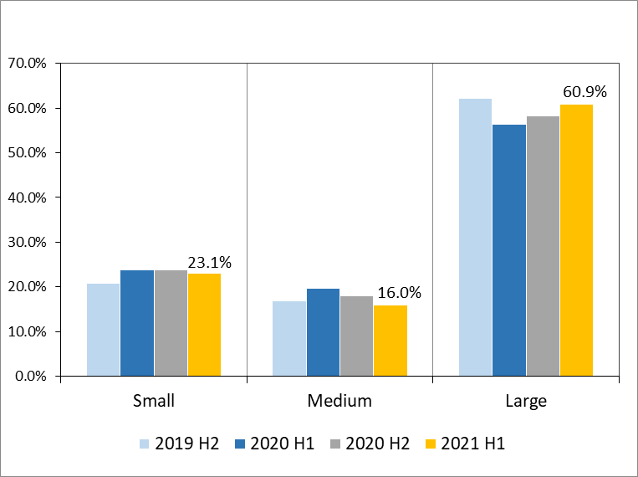 | 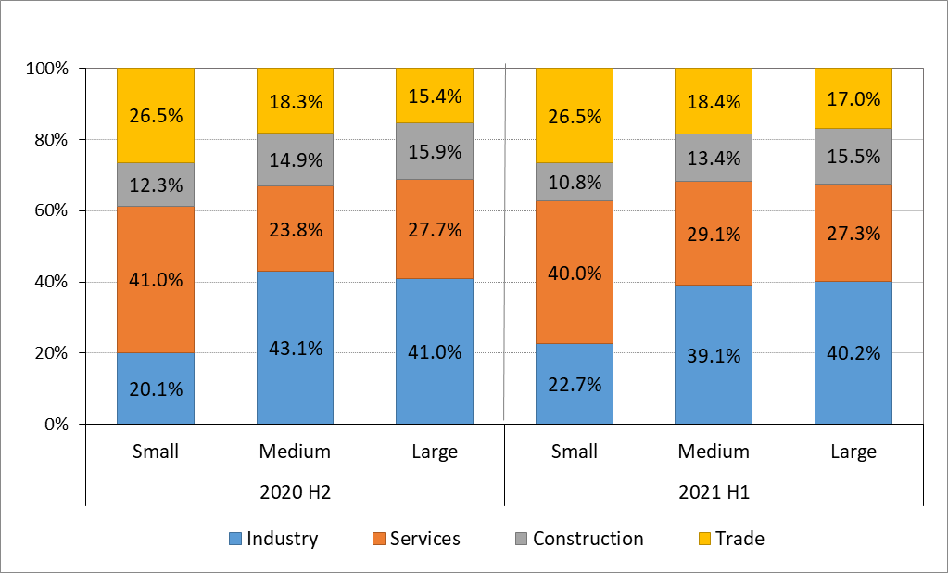
Source: Bank of Albania.

1.2 Obtaining raw materials and selling products

The main share of enterprises (around 57% of small enterprises, 48% of medium-sized enterprises and 36% of large ones) obtain over 80% of raw materials domestically. Compared with the previous period (2020 H2), this indicator decreased for small and large enterprises by 6 p.p. and 1.8 p.p., respectively, while it increased by 4.1 p.p. for medium-sized enterprises. On the other hand, around 37% of large enterprises obtain up to 20% of raw materials domestically with a six-month increase of 1.9 p.p.

Products continue to be sold mainly within the country, with around 83% of small enterprises, 67% of medium-sized enterprises and 54% of large enterprises claiming to have sold most of their products in the domestic market (over 80% of products volume). Compared to the previous six months, there has been an increase in the share of medium-sized enterprises selling their products mainly domestically (by 3.3 p.p.), while the share of small and large enterprises claiming such thing marked a slight decline (by 2.6 p.p. and 1 p.p., respectively).

Chart 1.3 Distribution of enterprises share of commodities bought domestically | Chart 1.4 Distribution of enterprises by share of sales domestically
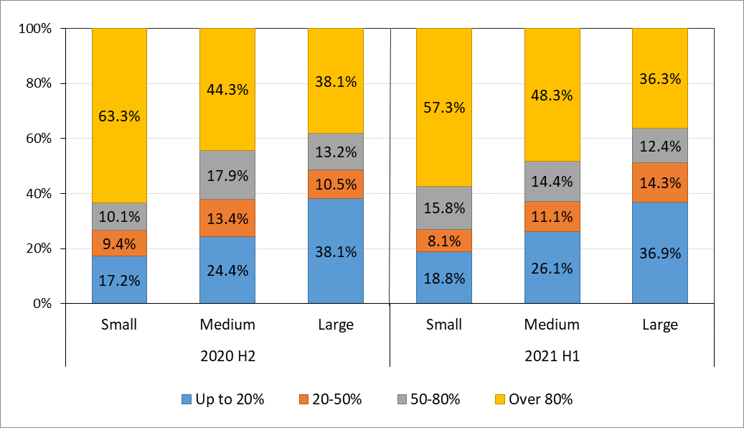 | 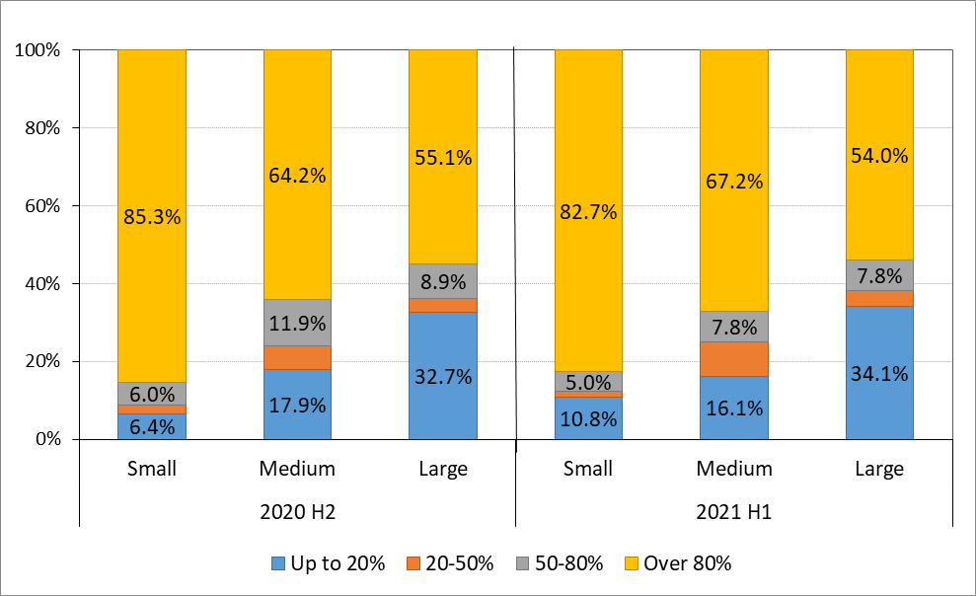
Source: Bank of Albania.

The analysis of responses by sector shows that the construction sector has a greater reliance on the raw materials provided domestically - around 72% of the enterprises in this sector obtain over 80% of raw materials domestically. This share decreased by 6.7 p.p. compared to the previous six months, and 3.1 p.p. compared to the previous year. On the other hand, the industry sector shows lower reliance with 53% of the enterprises in this sector obtaining only 20% of raw materials domestically. The share of these enterprises registered a six-month increase of 1.6 p.p., while in annual terms this increase was 4.7 p.p.

Table 1.1 Enterprises by sector and percentage of purchasing raw materials domestically
 |  | Up to 20% | 20-50% | 50-80% | above 80%
Industry | 2019 H2 | 48.9% | 8.6% | 14.7% | 27.8%
 | 2020 H1 | 47.9% | 13.4% | 13.4% | 25.3%
 | 2020 H2 | 51.0% | 13.1% | 13.1% | 22.9%
 | 2021 H1 | 52.6% | 14.1% | 9.1% | 24.2%
Services | 2019 H2 | 18.2% | 5.7% | 13.1% | 63.0%
 | 2020 H1 | 16.7% | 5.6% | 12.0% | 65.7%
 | 2020 H2 | 20.1% | 6.7% | 10.2% | 63.0%
 | 2021 H1 | 18.4% | 6.4% | 14.3% | 60.8%
Construction | 2019 H2 | 1.3% | 3.2% | 19.0% | 76.6%
 | 2020 H1 | 3.7% | 2.5% | 18.4% | 75.5%
 | 2020 H2 | 3.0% | 1.2% | 16.8% | 79.0%
 | 2021 H1 | 4.4% | 3.1% | 20.1% | 72.3%
Trade | 2019 H2 | 30.6% | 14.5% | 19.2% | 35.8%
 | 2020 H1 | 32.7% | 19.5% | 14.6% | 33.2%
 | 2020 H2 | 31.4% | 20.3% | 16.4% | 31.9%
 | 2021 H1 | 29.7% | 24.7% | 16.4% | 29.2%
Source: Bank of Albania.

1.3 Constraining factors in the activity of enterprises
During the period, the highest assessment of the impact on business continues to be the "situation created by the pandemic”, which also aggravated other problems faced by enterprises. Following, surveyed enterprises report that “competition” and “finding a market” continue to be a challenge for their activity. The importance of “competition” has increased compared with the previous period for all enterprise sizes, similarly to finding a market. Factors which have shown an increase in assessment during this period are “access to finance”, “cost of funding” and “availability of qualified staff”, particularly for small and large enterprises.
Chart 1.5. Assessment of some constraining factors in the activity of enterprises
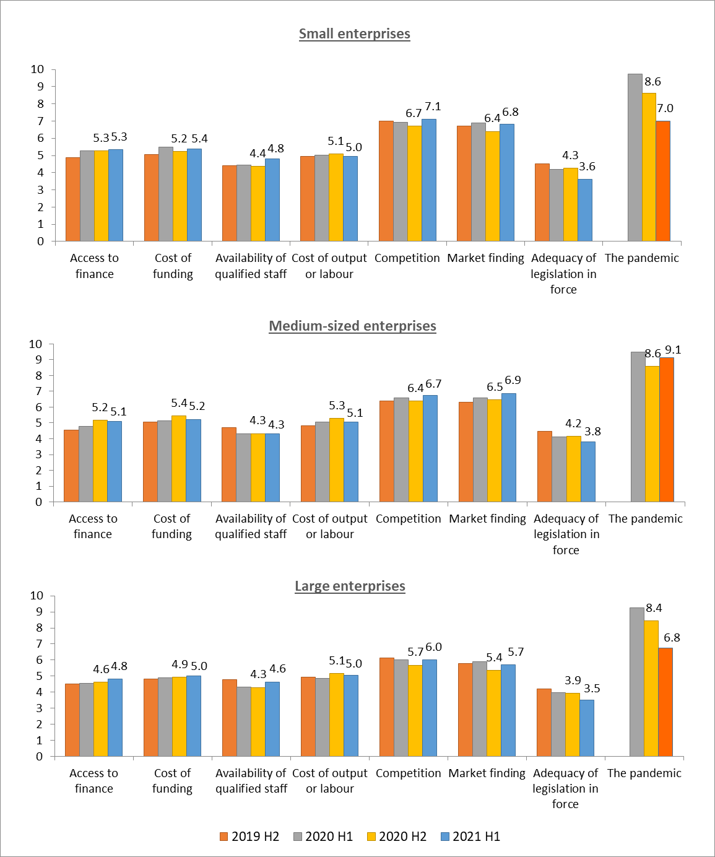
Source: Bank of Albania.

2. Financial performance of enterprises and the presence of debt

2.1 The operating currency of the activity
Euroisation of the activity of small and medium-sized enterprises continues to remain low, but is more significant in large enterprises. Thus, around 13% of small enterprises and 20% of medium-sized enterprises state that they carry out their activity completely or mainly in foreign currency. This indicator is around 36% for large enterprises, up by 1.8 p.p. in this period.

Chart 2.1 Distribution of enterprises by size and operating currency
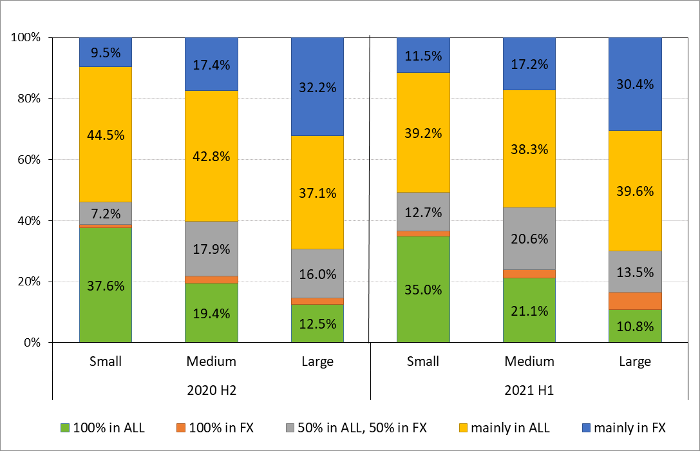
Source: Bank of Albania.

2.2 Sales performance, financial result and expansion of activity
During the period, sales declined for small and medium-sized enterprises, but increased for large enterprises. Thus, small and medium-sized enterprises continue to report a decline in sales with a negative net balance of [-36.9%] and [-20.6%], respectively, but improving compared with the previous six months, clearly reflecting the challenging situation created by the SARS-CoV-2 pandemic. The situation appears different for large enterprises, which recorded a positive net sales balance of [4.8%], showing an increase in the overall sales after two six-month periods of decline. Expectations on total sales over the next six months are quite optimistic for the three groups of enterprises. More specifically, medium-sized enterprises have a positive net balance of 56.1%, followed by large enterprises, which have a positive net balance of 51.3% and small enterprises with 49.2%.

Chart 2.2 Net sales balance Chart 2.3 Net expectations sales balance
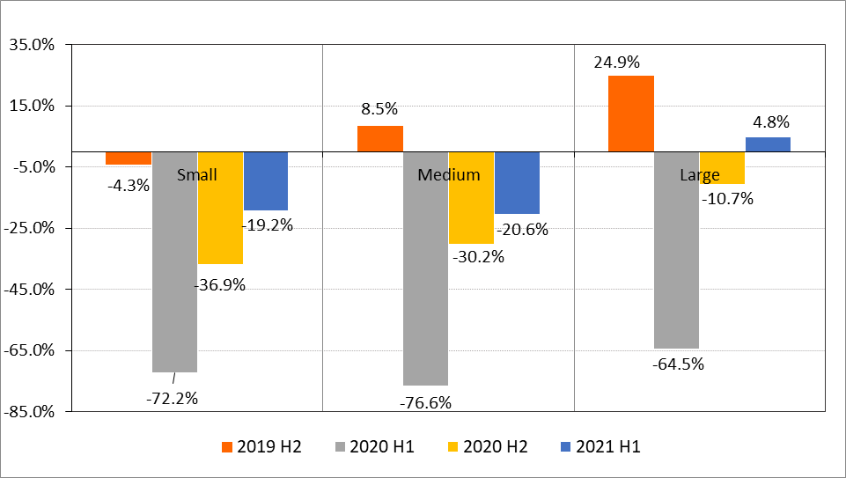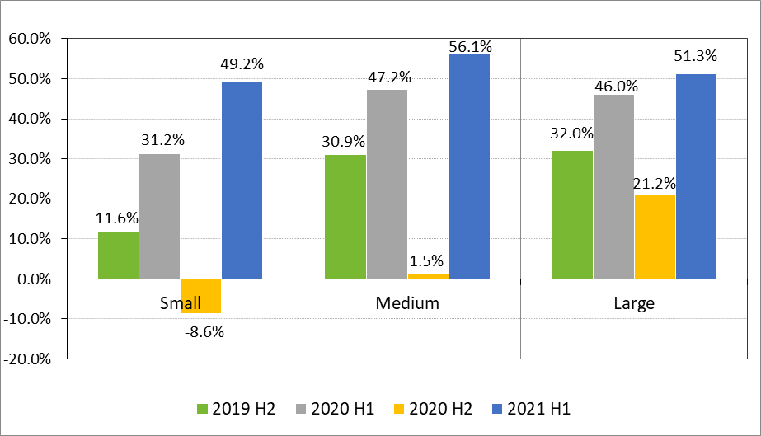
Source: Bank of Albania.
Net balances of responses are calculated as the difference between the weights of positive responses (sales growth/sales expectations growth) and negative responses (sales decline/sales expectations decline) to the total of answers provided.

Most of small and medium-sized enterprises reported a decline of the financial result, whereas large enterprises have shifted to positive territory. Thus, small and medium-sized enterprises estimate a decline in the financial result, with a negative net balance of [-21.2%] and [-22.3%], respectively, but contracted compared to the previous two periods. Large enterprises declare a positive balance of financial result by [2.9%], after two six-month periods of decline. The expectations for the next six-month appear optimistic for all enterprise sizes.
Chart 2.4 Net balance of the financial result Chart 2.5 Net balance of the expected financial result over the next six months
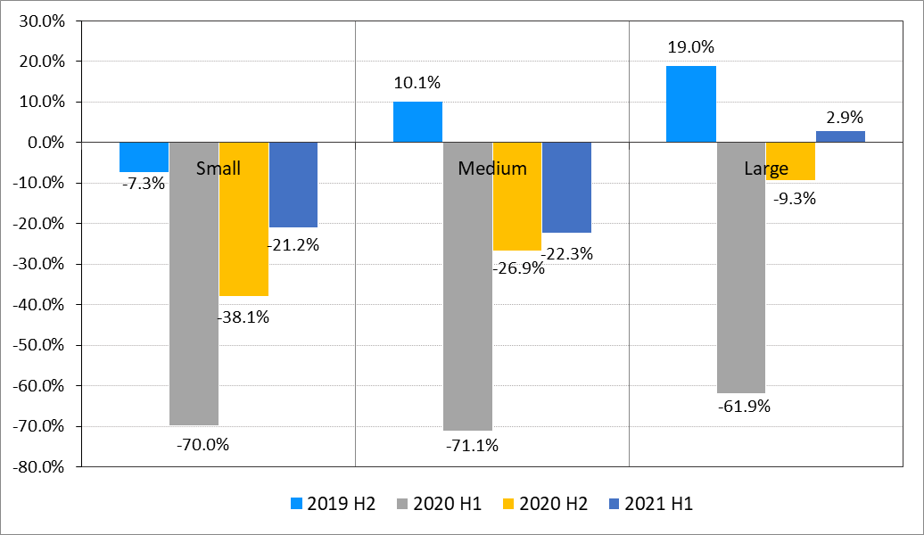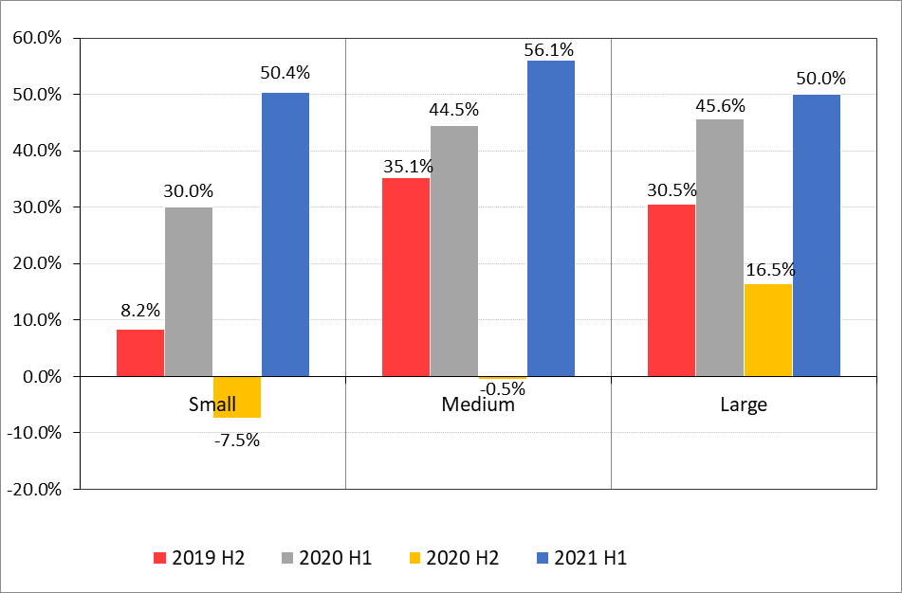
Source: Bank of Albania.
Net balances of responses are calculated as the difference between the weights of positive responses (financial result growth/expectations growth) and negative responses (financial result decline/decline of expectations) to the total of answers provided.

The assessment of enterprises for investment growth and activity expansion signal positive developments. Small and large enterprises registered positive net balances of 3.8% and 10.7%, respectively. Whereas, medium-sized enterprises continue to declare a negative balance of [-0.6%]. The pandemic continues to have an impact on the decision-making of enterprises regarding investments or the expansion of their activity, however, the half-year growth of this balance gives positive signals of recovery. For the next six-months, the net balances of responses resulted positive for all enterprise seizes, implying expectations for investments or further activity expansion. Compared with the previous surveyed periods, these expectations are more optimistic even than the pre-pandemic period.

Chart 2.6 Net balance of activity expansion Chart 2.7 Net balance of activity expansion over the next six months
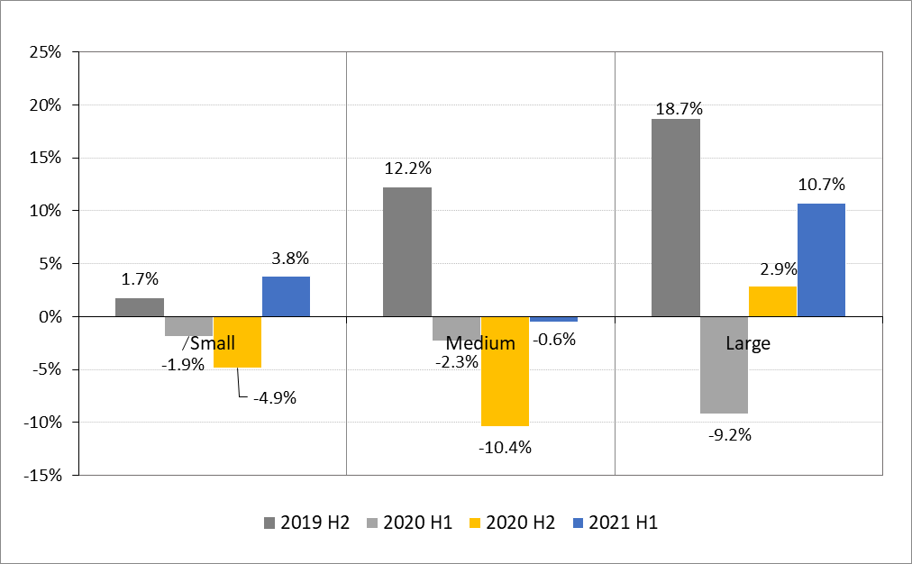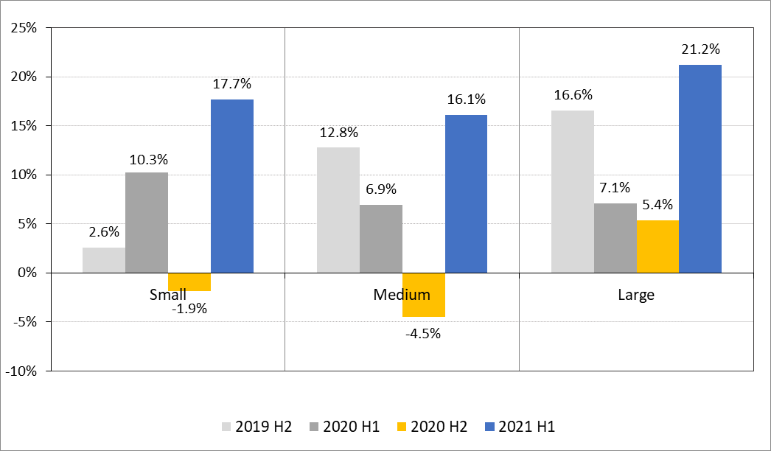
Source: Bank of Albania.
Net balances of responses are calculated as the difference between the weights of positive responses (expansion of activity/expectations for expansion or investments) and negative responses (contraction of activity/expectations for contraction) to the total of answers provided.

2.3 Sales level and financial result
The aggregated performance of total sales is analysed through an index that weighs the responses of enterprises at different intervals and groups them by size of enterprises and sectors.

The performance of the sales index indicates their improvement during the period compared with 2020 H2, although it has not reached the level of the pre-pandemic period. By size, the performance of the values of the index indicates an increase of overall sales for small and medium-sized enterprises, whereas it has remained unchanged for large enterprises. The index increased for all three group sizes compared with the previous year. A semi-annual and annual increase is observed for all sectors of the economy. Compared with the previous six-months, the results of the index by sector indicate a decline of overall sales for the trade sector. According to this index, the highest values of sales were achieved by the construction and trade sectors, while the lowest values continue to be in the services sector.

Chart 2.8 Overall sales index by enterprise size Chart 2.9 9 Index of total sales by sectors
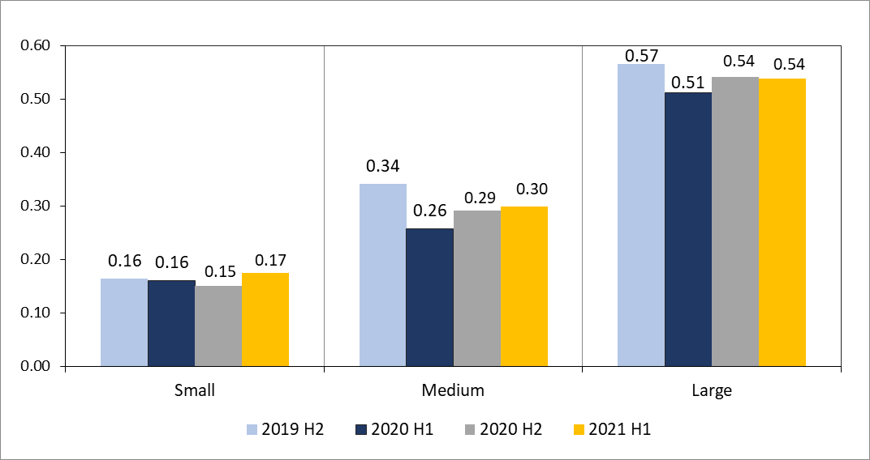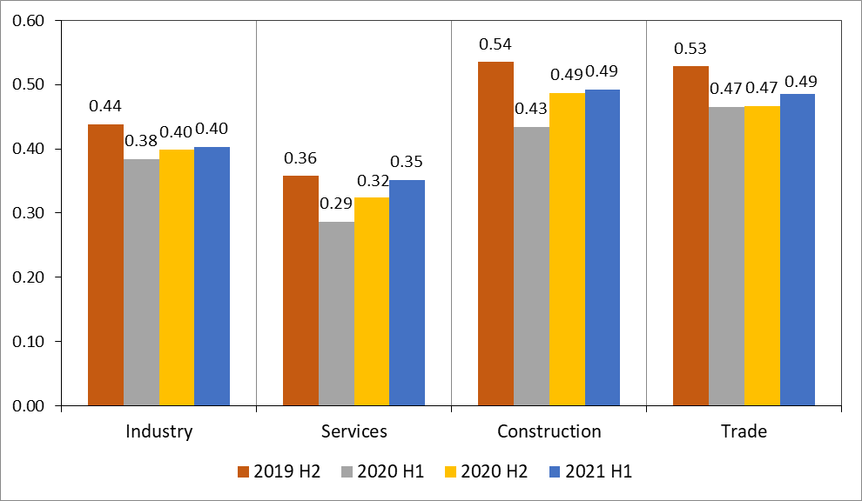
Source: Bank of Albania.

Regarding the financial result in 2021 H1, over 87% of the responding enterprises in each size group reported profit during the period. This percentage was higher for large enterprises (around 92%) and lower for medium-sized enterprises (around 87%). The share of enterprises that reported profit was upwards for small enterprises, compared to the previous period.

Chart 2.10 Financial result by size of enterprises
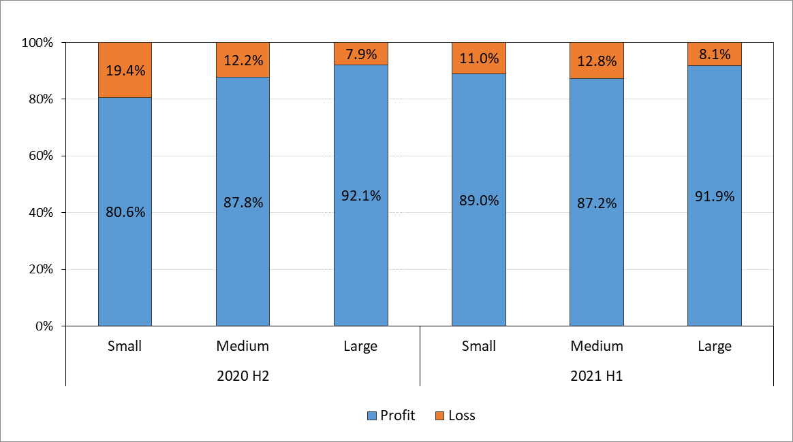
Source: Bank of Albania.

For profit reporting enterprises, small and medium-sized enterprises have a negative balance of sales and financial result, while the expansion of activity presents positive balances for small and large enterprises. Net balances of large enterprises are improving in terms of sales and financial result compared to 2020 H2. In terms of expectations for the next six-months, profitable enterprises of all sizes appear quite optimistic compared with the previous period, particularly in relation to sales and financial result.

Chart 2.11 Net balances for profit reporting enterprises | Chart 2.12 Net balances of expectations for profit reporting enterprises
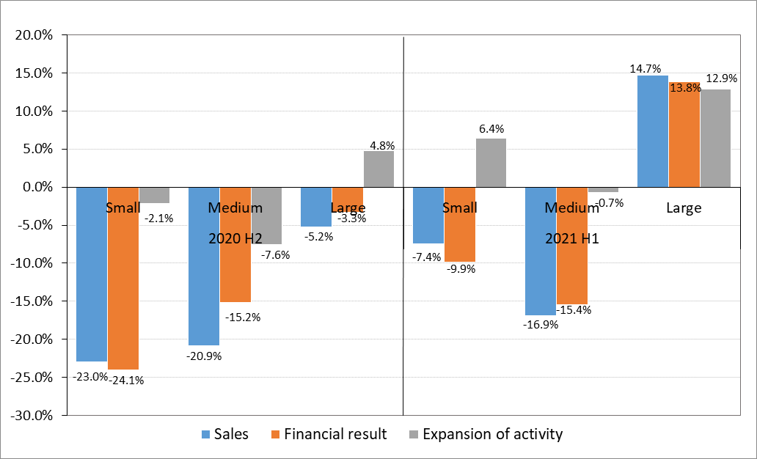 | 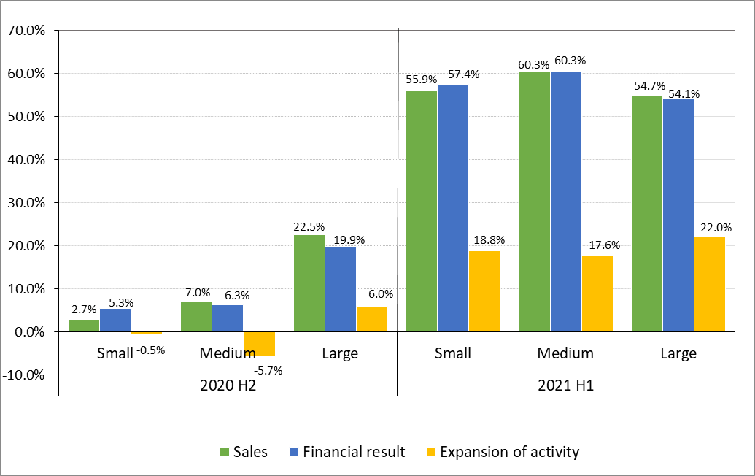
Source: Bank of Albania.

For loss reporting enterprises, all the three groups report negative balances for sales level, financial result and expansion of activity or investment growth during the period. However, these balances have contracted compared to the previous period. The expectations for those enterprises reporting a loss have shifted to a positive territory, appearing quite optimistic for the next six months regarding the next level of sales, financial result and expansion of activity for all sizes of enterprises.

Chart 2.13 Net balances for loss reporting enterprises Chart 2.14 Net balances of expectations for loss reporting
enterprises
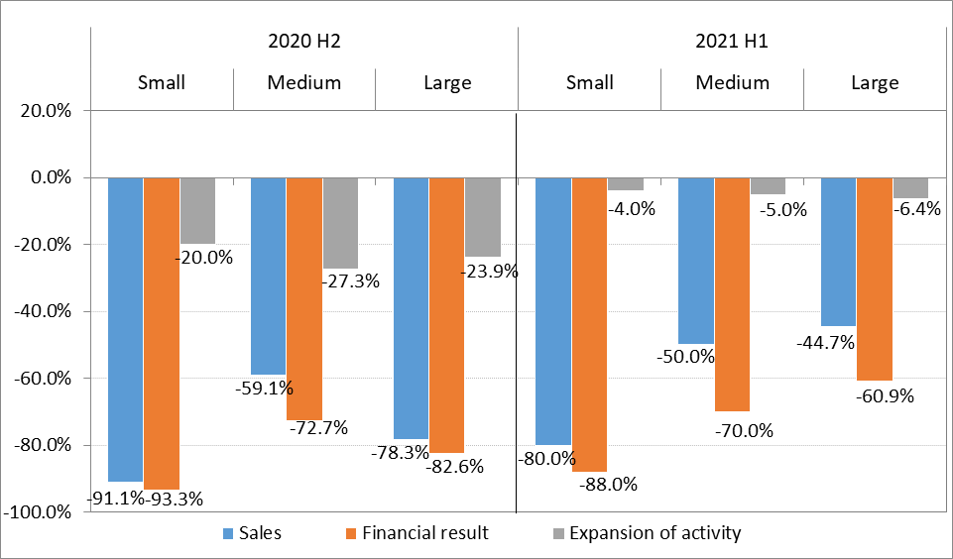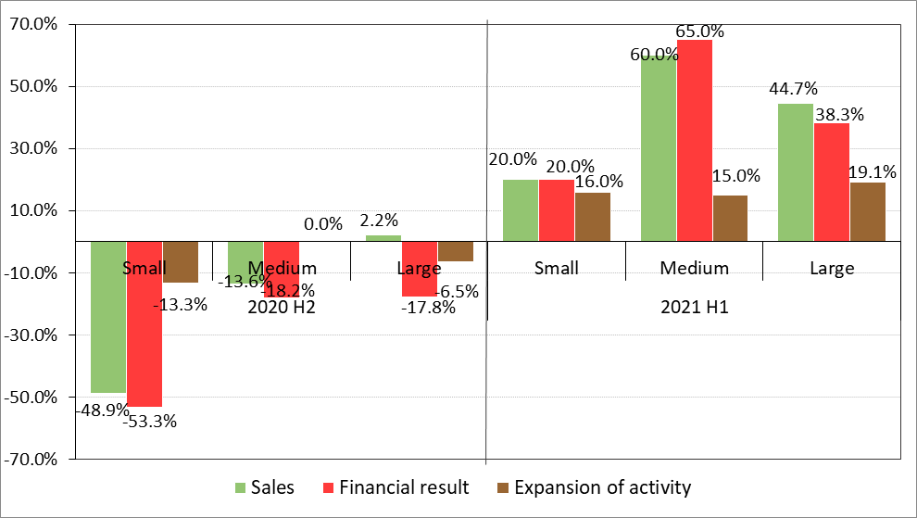
Source: Bank of Albania.

2.4 Financing the activity
During the period, around 46% of enterprises have continued to finance their activity only through sales (52% of small enterprises, 43% of medium-sized enterprises and 45% of large ones), recording a decline for all groups of enterprises by size. Meanwhile, the trend of combining different sources of financing continues to account for a considerable share during the period, expanding for all groups of enterprises. Financing achieved through the combination of sales with accumulated reserves has the main share in this regard.

Chart 2.15 Activity financing sources by size of enterprises
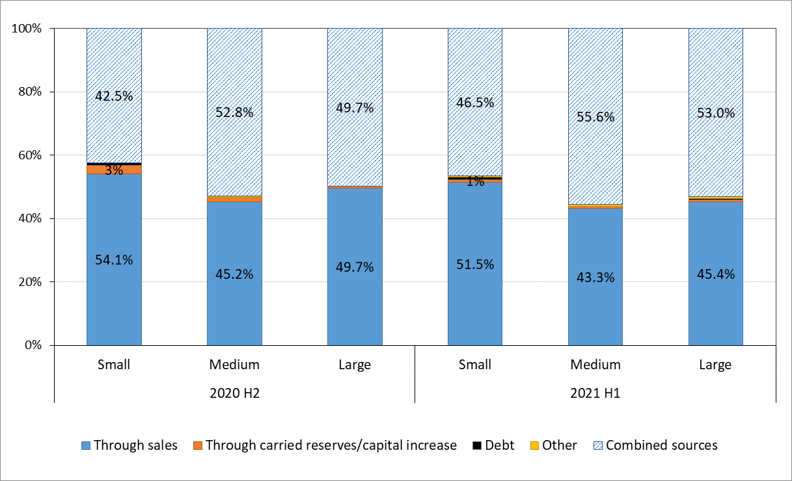
Source: Bank of Albania.

3. Characteristics of enterprise borrowing
Around 40% of total responding enterprises (454 enterprises) claim that they are indebted. This share has registered a decline of 0.9 p.p. compared to the previous six-months, but it has increased by 0.7 p.p. compared to the previous year. In terms of enterprise size, the share of borrowing enterprises decreased for small and large enterprises by 3.6 p.p. and 0.8 p.p., respectively, while it increased by 0.5 p.p. for medium-sized enterprises. By sector, the highest share of borrowing enterprises results in the trade sector (around 51%), although downwards for the period, followed by the construction sector (42%).

Table 3.1 Enterprises by size and borrowing
Borrowing enterprises by size | No. of enterprises |  | Share to total of the group
 | 2020 H2 | 2021 H1 | 2020 H2 | 2021 H1
Small | 86 | 74 | 32.1% | 28.5%
Medium-sized | 81 | 73 | 40.1% | 40.6%
Large | 299 | 306 | 45.6% | 44.7%
Total enterprises | 466 | 454 | 41.2% | 40.3%
Source: Bank of Albania.

The following analysis is performed relying solely on the responses of borrowing enterprises.

3.1 Source of borrowing
Around 90% of borrowing enterprises claim that in terms of borrowing they mainly relied on the banking sector, while almost 5% have used a combination of sources. The share of enterprises borrowing from banks has increased by 2.1 p.p. compared with 2020 H2. By size, around 88% of small enterprises, 93% of medium-size ones and 90% of large enterprises have borrowed only from banks. This share has continued to increase for small enterprises and also for large and medium-sized ones compared with the previous six-months. In addition to banks, part of enterprises have also borrowed from non-bank financial institutions or have combined formal and informal sources (like borrowing from natural persons, other companies, unpaid goods).

Chart 3.1 Distribution of enterprises by source of borrowing
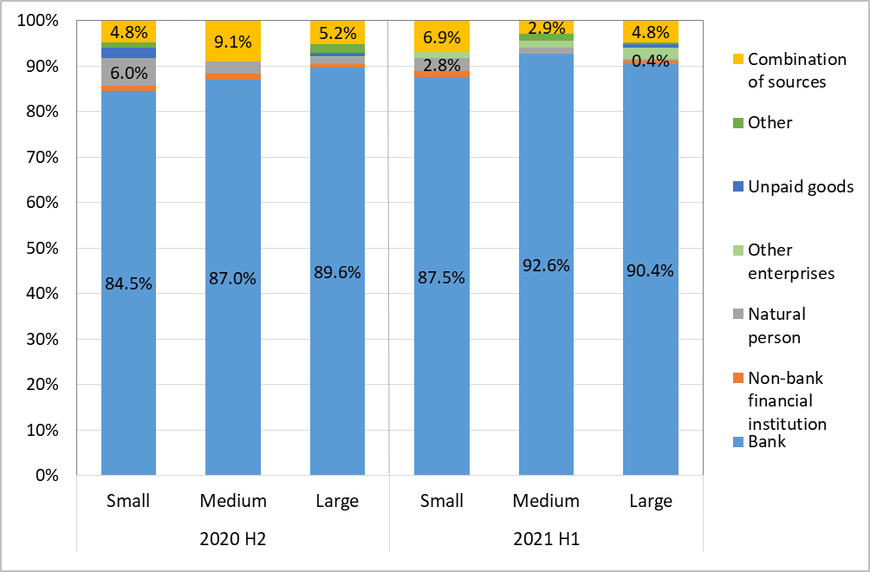
Source: Bank of Albania.

In total, formal borrowing sources (from banks and non-bank financial institutions) were used by 92% of responding borrowing enterprises (around 93% of small enterprises, 96% of medium-sized ones and 92% of large ones), at 2 p.p. more compared with the previous six-months. The combination of formal and informal sources has been used by 3.4% of enterprises.

3.2 Purpose of borrowing
Borrowing of all sizes enterprises to cover short-term expenditure registered an increase during the period. Compared with the previous six-months, the share of enterprises that have borrowed for an investment has registered a decline for small and medium-sized enterprises. A decrease of combined purposes of borrowing is observed, where the two purposes above have the main share for all sizes of enterprises.

Chart 3.2 Distribution of enterprises by purpose of borrowing
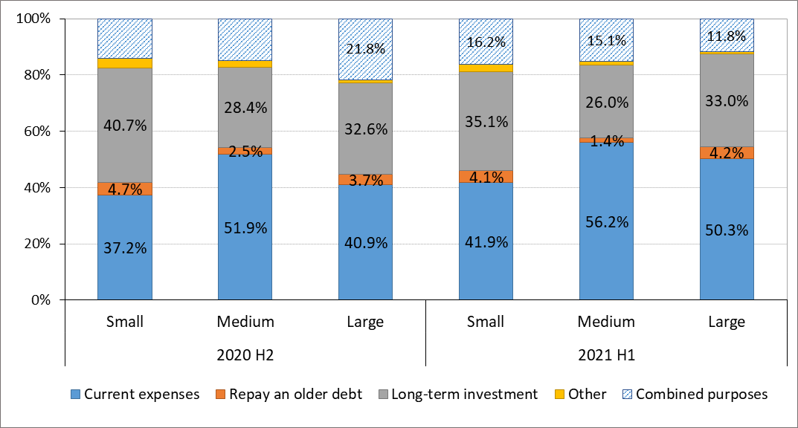
Source: Bank of Albania.

3.3 Debt adequacy
During the period, more than 3/4 of enterprises consider the level of borrowing as adequate for financing their activity. This indicator is around 77% of small enterprises, 85% of medium-sized enterprises and 87% of large ones. Compared with the previous period, this share has increased for all sizes of enterprises. The other part of responses resulted in positive net balances for medium-sized and large enterprises, while small enterprises present a negative balance. This balance indicates that the share of enterprises that would prefer to borrow more is higher than the share of those that would prefer to borrow less in order to finance their activity. Comparing this result with that of the previous survey, credit demand appears lower for the period under review.

Chart 3.3 Distribution of enterprises by loan adequacy
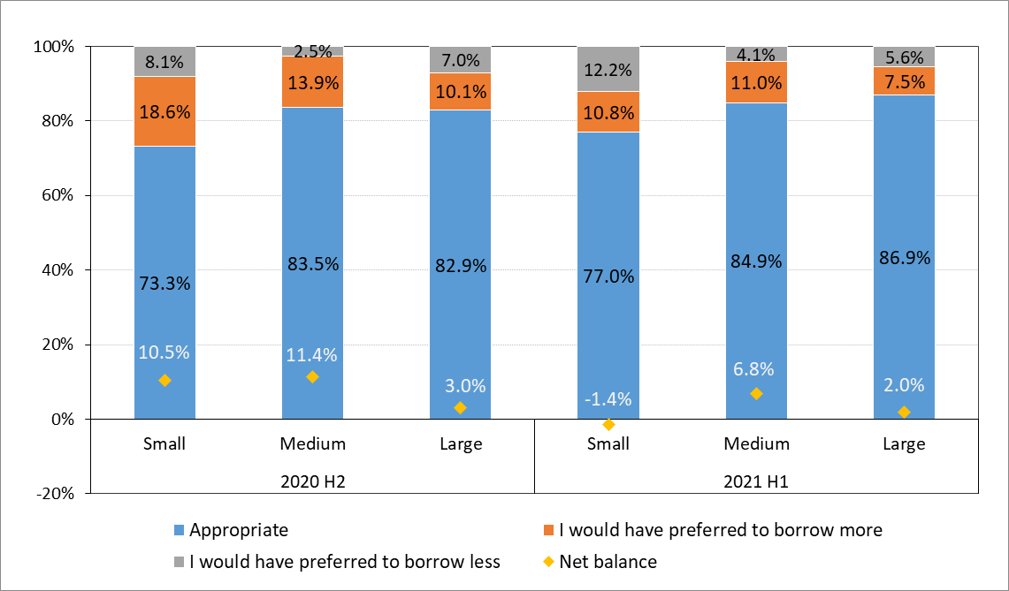
Source: Bank of Albania.

4. Debt structure

4.1 Currency
By currency, borrowing appears relatively balanced. Over the period, 60% of small enterprises, 65% of medium-sized enterprises and 45% of large enterprises, declare that their borrowing is only in domestic currency, while the rest in foreign currency (euro and/or US dollar) and/or combined (ALL and foreign currency). During the period, borrowing in foreign currency (mainly in euro) resulted more used by large enterprises (around 41%) and less by small and medium-sized enterprises (36% and 31% respectively). This factor is also affected by the currency with which these enterprises carry out their activity. Compared with the previous six-months, the share of enterprises with foreign currency borrowing resulted downwards for all three groups of enterprises (by 1 p.p. for small enterprises, 18 p.p. for medium-sized enterprises and 3 p.p. for large ones).

Chart 4.1 Distribution of enterprises by loan currency
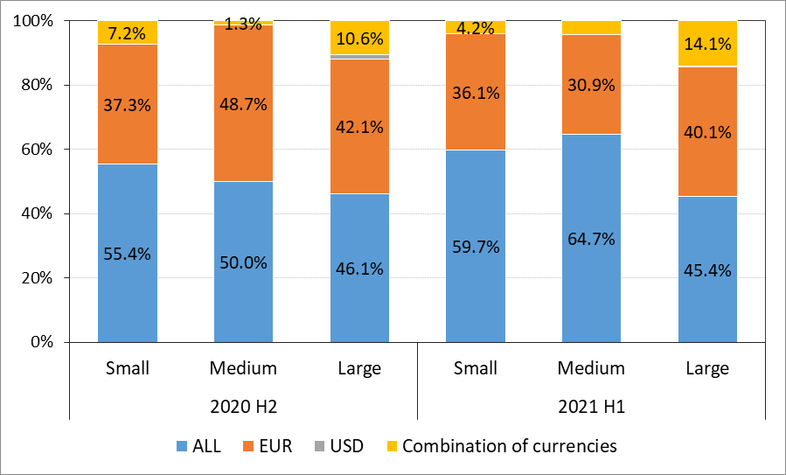
Source: Bank of Albania.
4.2 Debt and maturity
The share of enterprises that have borrowed in the past 1-5 years is around 15% for small enterprises, 55% for medium-sized enterprises and 45% of large ones. Compared with the previous six months, this share registered an increase for all sizes of enterprises (by 11.7 p.p. for small enterprises, 5.4 p.p. for medium-sized enterprises and 5.2 p.p. for large enterprises).

New borrowing, which means borrowing in the last six-months, is declared by around 7% of small enterprises, 14% of medium-sized enterprises and 9% of large ones. In semi-annual and annual terms, the share of new borrowers resulted downwards for small and large enterprises. The main purpose of use of new borrowing has been to cover short-term expenditures (for 86% of the total responding enterprises) and to make a long-term investment (12% of total enterprises). Compared with the previous six-months, the share of enterprises that have newly borrowed to face current expenditures, has increased significantly. The average maturity of borrowing resulted 64.8 months for small enterprises, 64.9 months for medium-sized enterprises and 62.2 months for large ones.

4.3 Interest rate and repayment
The main type of interest rate for the largest existing debt, remains fixed interest rate up to maturity (for 77% of small enterprises, 69% of medium-sized enterprises and 77% of large ones) and the yearly variable rate (for 15% of small enterprises, 21% of medium-sized enterprises and 17% of large ones). During the period, the share of enterprises reporting fixed interest rate borrowing decreased compared to the previous period for all three groups of enterprises. The frequency of repayment continues to remain mainly monthly for 81% of small enterprises, 75% of medium-sized enterprises and 78% of large enterprises.

4.4 Collateral and coverage ratio
Around 64% of small enterprises, 59% of medium-sized enterprises and 67% of large enterprises, declare that debt is collateralized only through real estate, while the rest of the enterprises have used other forms of collateralization. Meanwhile, around 12% of small enterprises, 8% of medium-sized enterprises and 11% of large enterprises, admit that the debt is uncollateralized. Compared with the previous six-months, the share of enterprises with uncollateralized debt decreased for small and large enterprises, while the collateralization with financial instruments and guarantees continues to increase for all sizes of enterprises.

Collateral coverage is also assessed aggregately through a weighted response index. For 2021 H1, this index scored 0.49 for small enterprises, 0.48 for medium-sized enterprises, and 0.50 for large enterprises. The coverage ratio was upwards for small enterprises, compared to the previous period.

Chart 4.2 Distribution of enterprises by collateral Chart 4.3 Collateral coverage index
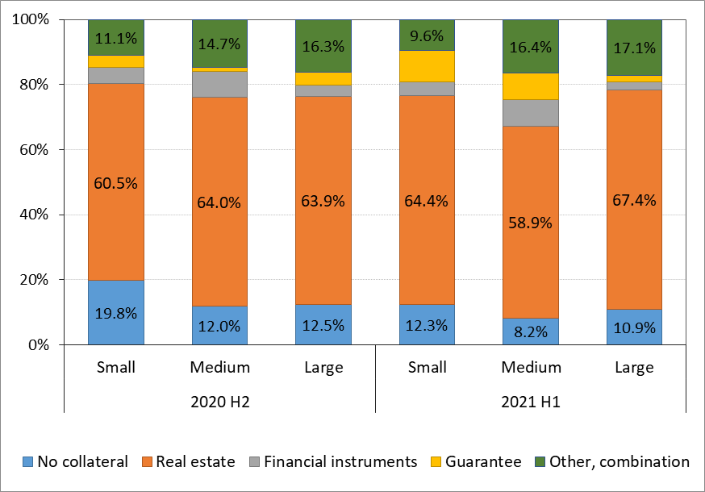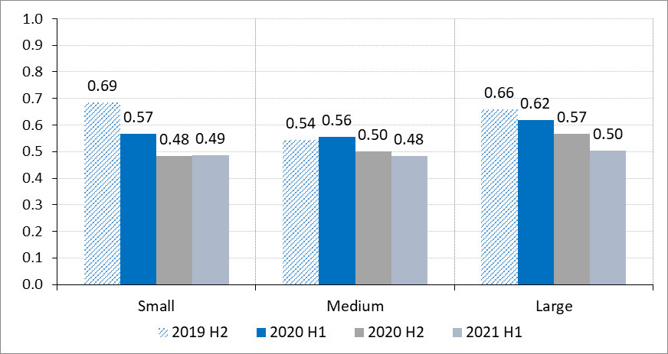
Source: Bank of Albania.

5. The debt burden

5.1 Debt value to equity
During the period, the total value of debt results approximately at half of the equity of the enterprise for 74% of borrowing enterprises and almost equal to the value of equity for 13% of them. The debt/equity ratio resulted higher for small and medium-sized enterprises, with 26% and 34% of them declaring that this ratio is equal or exceeds the value of equity, implying a higher debt burden. For 2021 H1, this ratio increased for all sizes of enterprises (by 8.2 p.p. for small enterprises, 10.8 p.p. for medium-sized enterprises and 1.6 p.p. for large ones).

Chart 5.1 Distribution of enterprises according to debt/equity ratio
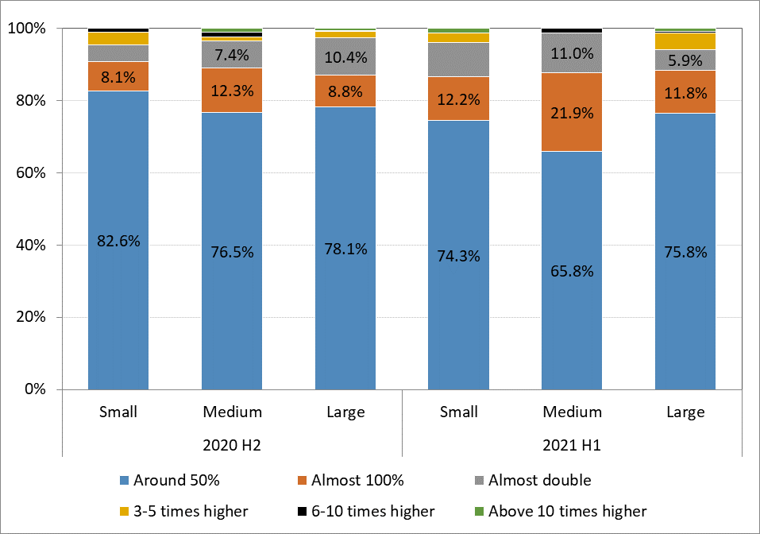
Source: Bank of Albania.

By sector, debt burden has increased for all the sectors under review. The debt burden appears higher for enterprises operating in construction and trade sectors.

Table 5.1 Share of enterprises with an equal/higher value of debt to equity, by sectors
Share of enterprises with an equal/higher value of debt to equity, by sectors
 | Industry | Services | Construction | Trade
2019 H2 | 20.4% | 28.0% | 13.4% | 26.5%
2020 H1 | 16.4% | 22.9% | 19.7% | 22.2%
2020 H2 | 19.7% | 25.0% | 17.6% | 21.9%
2021 H1 | 22.3% | 26.5% | 29.9% | 27.0%
Source: Bank of Albania.

5.2 Debt repayment
Most of the borrowing enterprises (76%) declare that debt repayment amounts up to 20% of their income. The share of these enterprises has decreased by 1 p.p. compared with the previous survey. The burden of debt service appears to be heavier on medium-sized enterprises, where the share of enterprises reporting that this payment exceeds 20% of income accounts for 26% of the total of the group. For small and large enterprises, this share is around 23%, respectively. Asked whether the debt service cost has changed over the period, the majority of enterprises (around 89% of small enterprises, 93% of medium-sized enterprises and 92% of large enterprises) claim that this expenditure has remained unchanged. The responses of the rest of the enterprises resulted in net positive balances for all sizes, showing an increase of this expenditure as a ratio to income. Nonetheless, this balance has decreased in both semi-annual and annual terms for all three groups of enterprises.

Chart 5.2 Distribution of enterprises according to Chart 5.3 Distribution of enterprises that declare debt repayment/ income ratio a change in debt repayment over the period
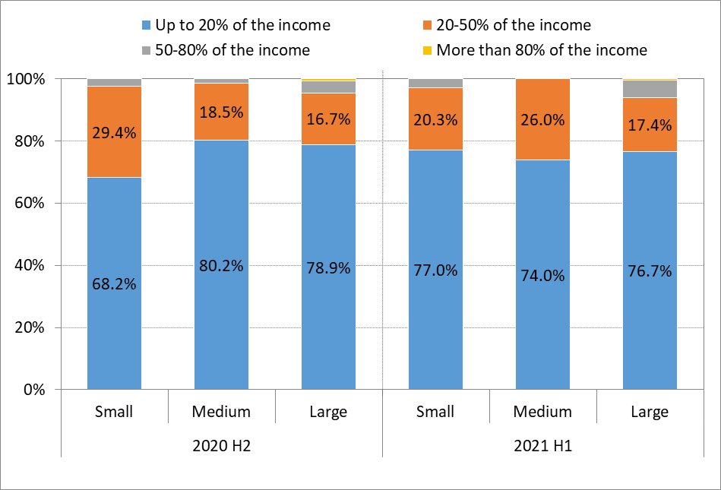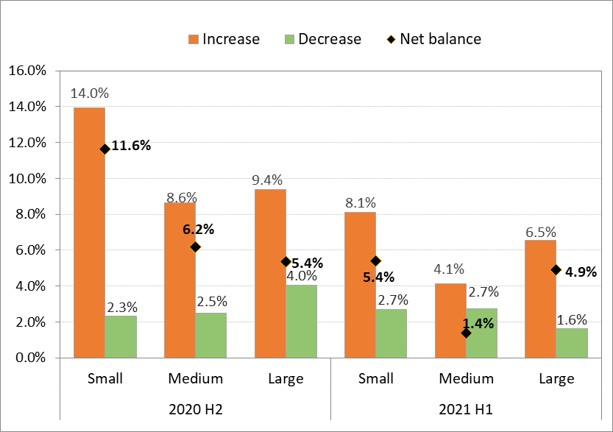
Source: Bank of Albania.

5.3 Coping with the loan cost
To compensate the increase of debt service costs, enterprises have relied mainly on the decrease of expenses (27%) or have used various reserves (27%). This modus operandi has been in line with responses of enterprises on the manner in which they finance their activity.

Chart 5.4 Coping with the cost of debt
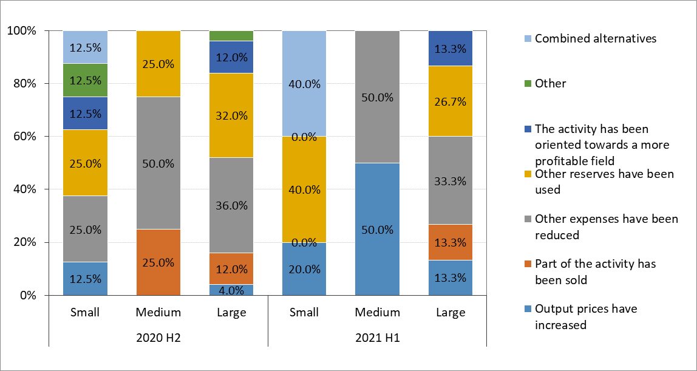
Source: Bank of Albania.

5.4 Debt burden
The debt burden of borrowing enterprises is assessed as upwards throughout the period, where the index value resulted 0.63 for total enterprises. Compared with 2020 H2 and by size, the index shows a higher debt burden for all sizes of enterprises.

Chart 5.5 Debt burden index
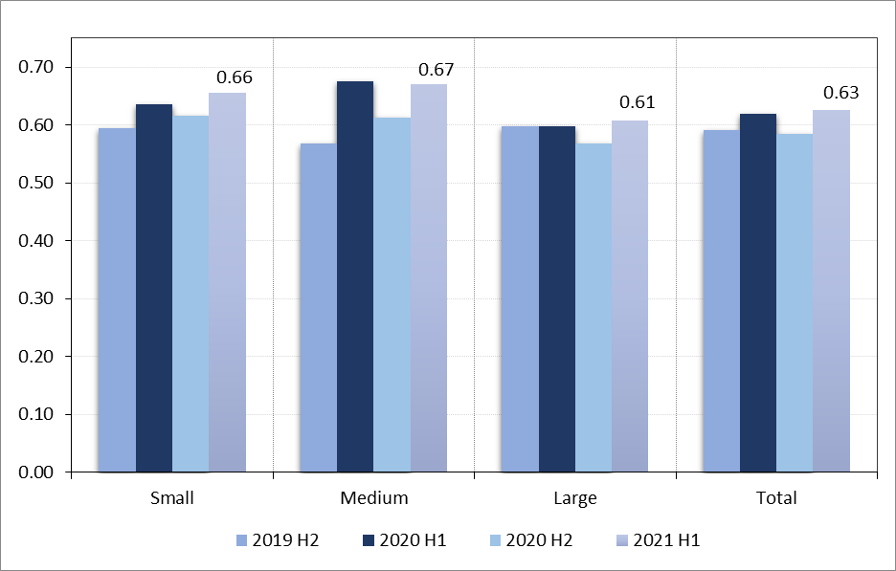
Source: Bank of Albania.

5.5 Expectations for debt repayment in the next six-months
Most of the borrowing enterprises (around 89%), despite their size, do not expect a change in the loan instalment in 2021 H2. This share has increased by 1.3 p.p. compared to the previous period. Regarding enterprises that expect a change of the instalment, small enterprises expect a decline in this regard. Meanwhile, medium-sized and large enterprises expect a positive net balance in the next period.

Chart 5.6 Expectations on change of loan instalment in the next six-months
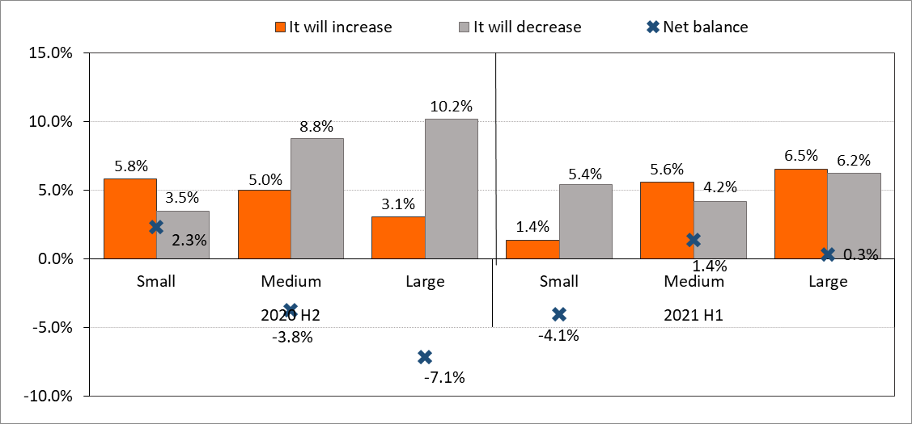
Source: Bank of Albania.

6. Relations with banks and expectations for the future

6.1 Access to financing
Enterprises’ demand for loans has continued to decline during the period, where 8% of them declare that they have applied for financing during the last six months. This share has contracted by around 3 p.p. for total enterprises compared with the previous survey. Analysing this indicator by size of enterprises, large enterprises continue to have the highest share for this period (around 12%). Compared with the previous six-months, a slight expansion of loan demand is observed only for medium-sized enterprises (by 0.3 p.p.), whereas small and large enterprises present a contraction of this demand (by 1.3 p.p. and 1.7 p.p., respectively).

Chart 6.1 Enterprises’ demand for financing
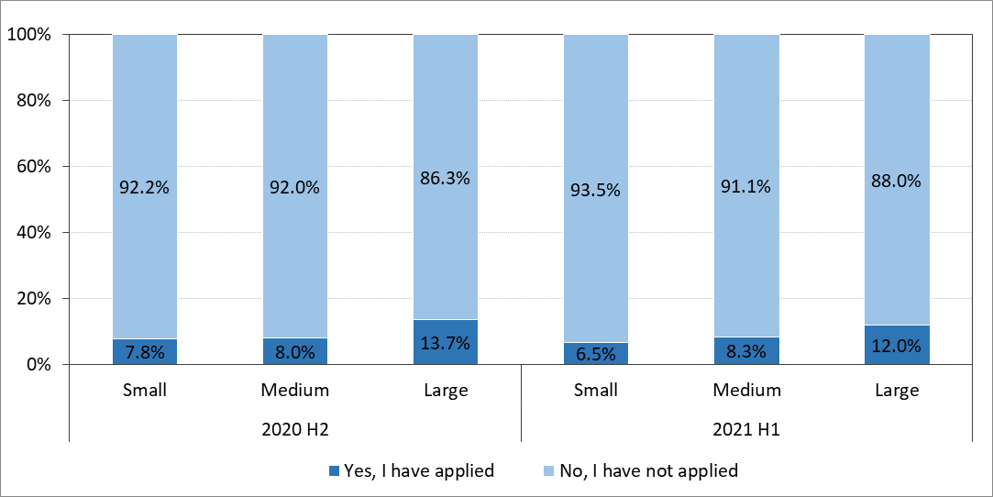
Source: Bank of Albania.

Enterprises that have not applied for a loan, in most cases, state mainly that it is not necessary for their activity. This share results higher for all sizes of enterprises, reflecting their contracted demand for loan. The rest of enterprises have decided to not apply, because the process seems difficult or because they assess that it is easier to borrow from alternative sources. Both these reasons present a decline for small and medium-sized enterprises in the analysed period.
Chart 6.2 Enterprises that did not apply for a loan, by size
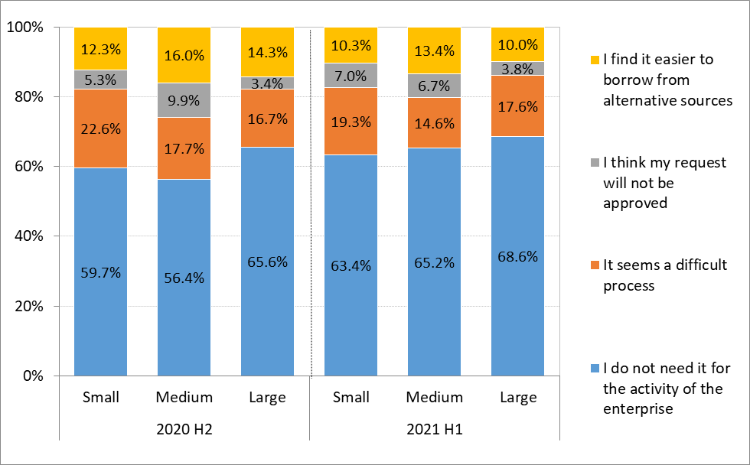
Source: Bank of Albania.

Asked on how they would behave if they were not financed by banks, more than 43% small enterprises declare that they would borrow from alternative sources, but with a decline of 3.4 p.p. compared with the previous six-months. Meanwhile, this share has decreased also for medium-sized (41%) and large enterprises (38%). Also, a significant share of enterprises state that they would apply again to another bank or other institution. Their share has increased significantly for all types of enterprises, aiming to achieve formal borrowing sources. The rest of enterprises declare that they will postpone their activity expansion plans due to lack of financing. This share has decreased for all sizes of enterprises.

Chart 6.3 Financing options, if not financed by banks
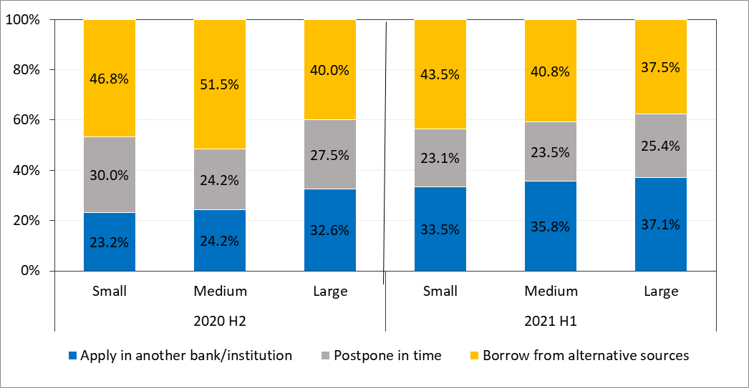
Source: Bank of Albania.

6.2 Borrowing process and relationship with banks
The index on the difficulty of bank borrowing process resulted at 0.38 for total enterprises during the period, unchanged compared with the previous period. This index remains between “normal” and “difficult”, for all three groups of enterprises. Compared with 2020 H2, the level of difficulty has declined for medium-sized enterprises.

Chart 6.4 The index on the difficulty of bank borrowing in Albania
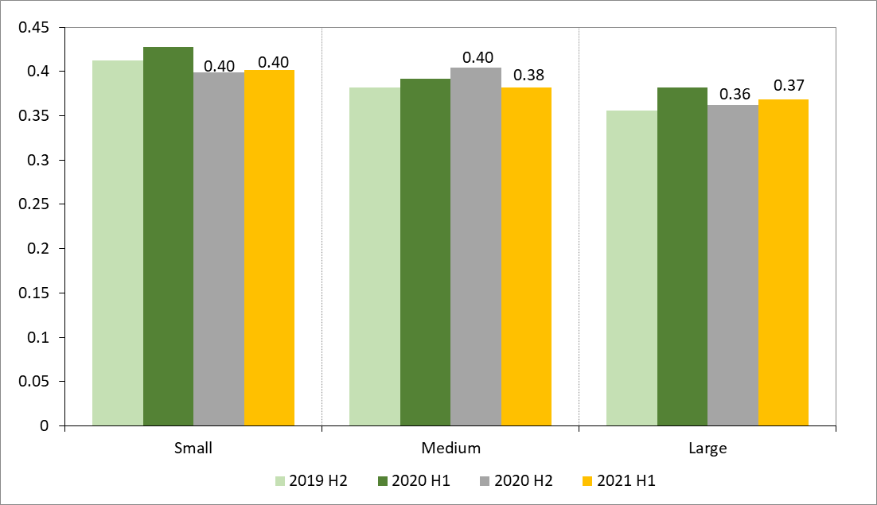
Source: Bank of Albania.

Relationship with banks, measured by the relevant index, continues to be assessed between “important” and “necessary”. This index decreased during 2021 H1 for all sizes of enterprises, following a period - during the pandemic - in which the relationship with banks increased and the loan demand appeared upwards.

Chart 6.5 Index on the relevance of enterprise-bank relationship
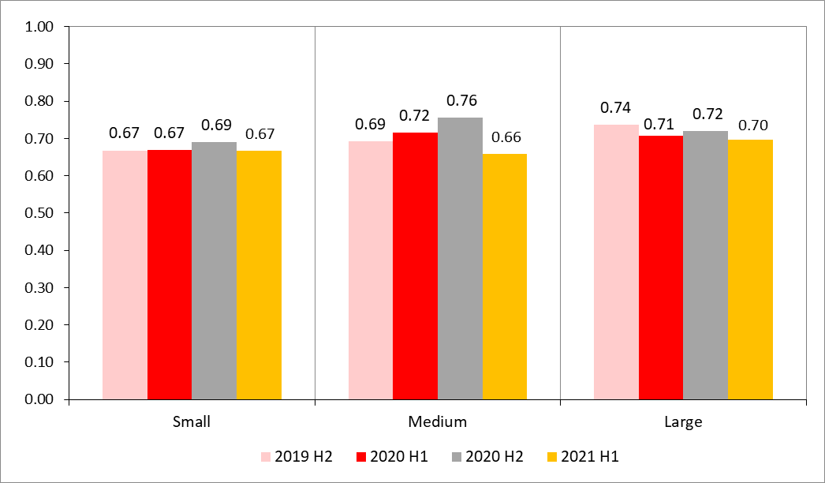
Source: Bank of Albania.

6.3 Difficulty of obtaining a loan
Although downwards, the loan cost continues to be considered as the main factor that makes it more difficult to obtain a bank loan, especially for small and medium-sized enterprises. The assessment for this element resulted in decline over these six-months for medium-sized and large enterprises. Following the loan cost, the cost of meeting bank requirements as well continues to remain a significant difficulty for all three groups of enterprises, followed by the assessment for loan guaranteeing terms and unclear bank requirements or bureaucratic procedures. However, these factors present greater difficulties for small enterprises in the surveyed period.
Chart 6.6 Constraining factors in bank borrowing process
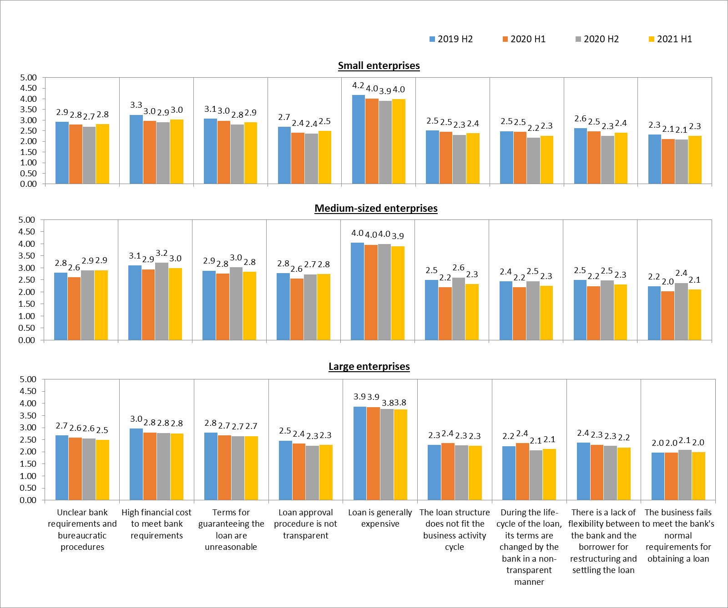
Source: Bank of Albania.

6.4 Borrowing plan

Regarding plans for borrowing in the next six-months, based on the responses of enterprises, the assessment is that loan demand has contracted. Almost 50% of responding enterprises reported “no possibility” of bank borrowing in the next period. This share has increased for all enterprise sizes compared with the previous periods. Furthermore, there is an increase of the share of enterprises that claim that it is “little likely” to take a loan in 2021 H2, as well as the share of small and large enterprises that declare that it is a “very likely” for this to happen in the next period. There is a slight increase for the alternative “definitely” for all sizes of enterprises, although this alternative accounts for the smallest share. The value of the index on assessment of borrowing plan for the next six-months was 0.43 for total enterprises. This index has contracted for all sizes of enterprises, in particular for small and large enterprises.

Chart 6.7 Distribution of enterprises by Chart 6.8 Borrowing plan index
borrowing plan
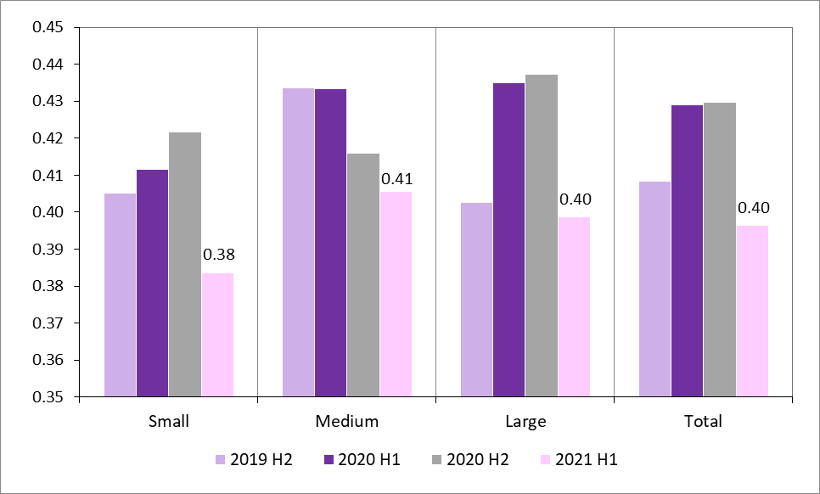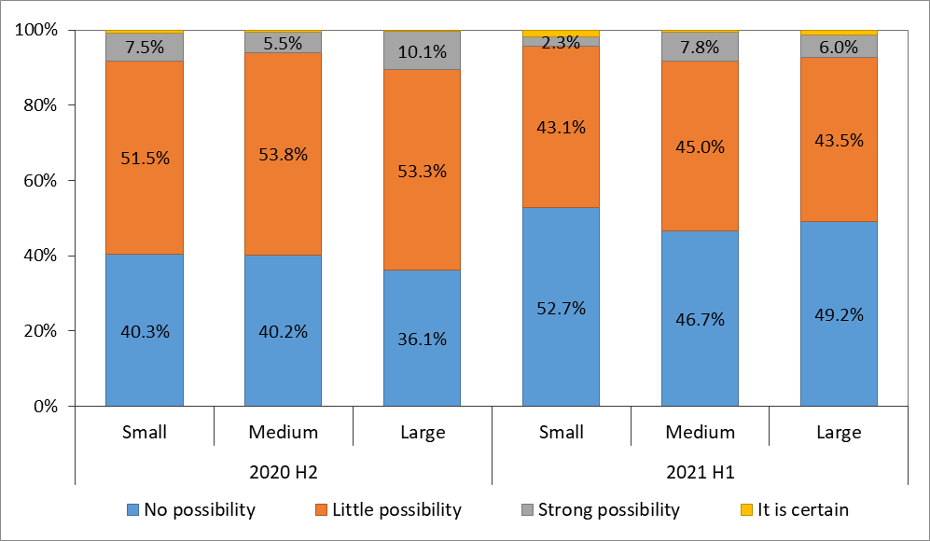
Source: Bank of Albania.

1 Due to the SARS-CoV-2 pandemic, the survey was gathered using various forms, in compliance with the preventive measures to minimize the spread of the virus (interviews at distance, e-mails and telephone). This survey covers developments on the financial and borrowing situation of enterprises for 2021 H1 as well as expectations for 2021 H2.
The survey on the financial and borrowing situation of enterprises has been conducted half-yearly since 2010. This survey was launched with a sample of top 700 enterprises with the highest annual net sales (large enterprises). In 2016, the sample expanded to include around 1200 large, medium-sized, and small enterprises across the country.
Enterprises have assessed the importance of certain issues on a scale rating from 1 to 10, where 1 is the lowest and 10 is the highest level of difficulty. To aggregate responses for each of the assessed issues, a weighted average is calculated by weighing the answers with the rating scales (1-10) for all responding enterprises.
This issue is defined in the alternative “Other” and is selected only by 3% of the sample of responding enterprises. In 2020 H1, this option was selected and specified by 37% of the responding sample and by 19% of them in 2021 H2.
Over 50% of the activity in foreign currency.
Weighting coefficients according to total sales intervals are: “Up to ALL 10 million” = 0; “ALL 10-49 million” = 0.25; “ALL 50-99 million” = 0.5; “ALL 100-500 million”= 0.75; “Over ALL 500 million” = 1. An increase/decrease in the value of this index means an increase/decrease in the total level of sales for enterprises.
Some 966 entities or around 70% of the sample responded.
Considering the full sample of 1374 enterprises, only 1127 of them or around 82% have responded
For enterprises that have more than one debt.
Financial instruments, guarantee, other warranties, along with the combination of some forms of collateralization, including the combination with real estate.
This index takes values from 0 to 1 and the increase in its value indicates an increase in the weight of collateral coverage. Based on each of the alternatives, the weighting coefficients of this index are: "Up to 50% of the collateralized debt" = 0.25; "50-100% of the collateralized debt” = 0.5; "100-120% of the collateralized debt" = 0.75; "Over 120% of the collateralized debt" = 1.
Calculated as the sum of weight for responses: “20-50% of total income”,”50-80% of total income” and “higher than 80% of total income:
The index is calculated by weighing the share of enterprises' responses to the total responses by the coefficients that take values of: 1 for "high burden", 0.5 for "average burden" and 0 for the "low burden" alternative.
The questions in this section are addressed to the entire sample of enterprises, including non-borrowing as well.
This index is calculated by weighing responses of enterprises against total responses according to a coefficient which increases with the increase of the difficulty of this process. The coefficient for the alternative “very easy” = 0, “normal” = 0.25, “difficult” = 0.5, “very difficult” = 0.75, “almost impossible” = 1.
The index is calculated by weighing the share of enterprises' responses to the total responses by the coefficients that take values of: 1 = "Necessary", 0.5 = "Important” and 0 = "Not quite important".
In order to assess the difficulty of obtaining a bank loan, enterprises have been asked to give their opinion on a number of qualitative elements, relying on a 5 degree rating system, where the lowest degree of difficulty is 1 and the highest is 5. In order to obtain an average rating for each qualitative element, scales from 1 to 5 are weighted with the weights of responses given by the enterprises.
To assess the responses of the enterprises, an index on borrowing plans was constructed, calculated by weighing the enterprise's responses to the total of responses by a coefficient which increases as the probability to borrow increases. The coefficient for the alternative: “no possibility” = 0.25; “little possibility” = 0.5; “probable” = 0.75; “certain” = 1.

